**2022.11.19卓越班英语周测参考答案（二）：作文参考答案汇总**

第一节（满分15分）假如你是李华,你的英国留学生朋友Jason参加了“留学生汉字书法竞赛（Chinese Calligraphy Competition for International Students）”并取得第一名的好成绩，请你给他写封信，内容包括：

1. 表示祝贺；

2. 肯定比赛结果和背后的努力；

3. 提出交流学习书法心得的请求。

注意：词数80左右

**（以下文章仅供内部交流， 旨在抛砖，欢迎切磋。转载需经作者同意，谢谢合作。）**

**Kelly’s version 1(应试版）**

Dear Jason,

Congratulations! You can’t imagine how thrilled and proud I am to hear the news that you’ve won the first place in the Chinese Calligraphy Competition for International Students.

No one but you deserves the championship and it came as no surprise to me. While others might admire you for your good luck and natural endowment, I’m firmly convinced it’s your attitude rather than your aptitude that determines your altitude. Your efforts eventually paid off! Struck by your outstanding attainment in Chinese calligraphy, I come up with an idea to compare notes with you in this field, which is also my hobby. Shall we fix a date?

Congratulations again and wish you greater progress! Looking forward to your early reply.

Yours, Li Hua

**Kelly’s version 2（酣畅版）**

Dear Jason,

Congratulations! You can’t imagine how thrilled and proud I am to hear the news that you’ve won the first place in the Chinese Calligraphy Competition for International Students.

No one but you deserves the championship and it came as no surprise to me. While others might admire you for your good luck and natural endowment, I’m firmly convinced it’s your attitude rather than your aptitude that determines your altitude. Just as Thomas Edison put it, genius is one percent inspiration and ninety-nine percent perspiration. The worn-out writing brushes with piles of Chinese art paper and empty bottles of prepared Chinese ink remind me of your years of persistent (relentless) practice by trial and error. Your efforts eventually paid off!

Struck by your outstanding attainment in Chinese calligraphy, I come up with an idea to compare notes with you in this field, which is also my hobby. Come on! Let’s dig into the amazing world with the profound and mysterious culture behind the beautiful Chinese characters! Shall we fix a date? For two friends from different backgrounds and cultures, it must be great fun as well as a win-win situation.

Congratulations again and wish you greater progress! Looking forward to your early reply.

Yours, Li Hua

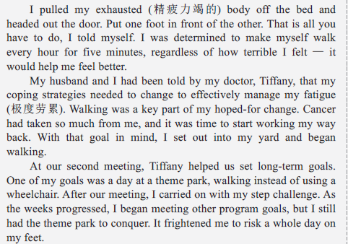第二节（满分25分）阅读下面材料，根据其内容和所给段落开头语续写两段，使之构成一篇完整的短文。

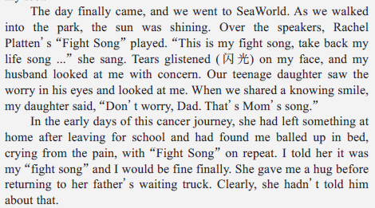

**注意：1. 续写词数应为150 左右；2. 请按如下格式在相应位置作答。**

**I walked from show to show that day. ______________________________________________________________________________________________________________________________________________________**

**My body cooperated on some days and let me down on others, but I kept walking. ______________________________________________________________________________________________________________________________________________________**

**One possible version**

I walked from show to show that day. I climbed stairs with purpose. I offered to get the food while my family saved us a table. I walked around the park practically overflowing with a sense of achievement. I was so proud that you would have thought I had run a long race. In a way, I had. Walking my way back to a life not controlled by fatigue was an exercise in determination. Every day, I tried to go a little farther than I had the day before.

My body cooperated on some days and let me down on others, but I kept walking. Through my walks, I began to see myself as an unstoppable force. Yes, cancer was and is a part of my life, but I will not let it describe who I am. Walking gave me my life back and changed the way I saw myself. Even now, when I have a difficult task ahead of me, I remind myself to just put one foot in front of the other.

**Version 2 :Michelle原创一稿 审稿人：Kelly**

**I walked from show to show that day.** Feet dragged, I felt out of breath before long. Dazzling as the shows were, for me, it was no fun watching any one. Instead, I just numbly edged my way through crowds, aiming to fulfill my risky and demanding goal. Suddenly, the melody of “Fight Song” echoed again, with an elderly singer in sight. My husband gave me an encouraging look, “How about joining him?” I just smiled with bitterness. Anyhow, I struggled to walk and went back, continuing to survive my cancer journey. ( 段1：在公园，不够积极面对”walking”)

**My body cooperated on some days and let me down on others, but I kept walking.** Despite intense pain and various barriers along the way, I never stopped saying to myself, “You are blessed with loving family members standing by your side, so please hold on”. Then came my next goal, given by my beloved daughter: to sing “Fight Song” on the stage, big or small. I didn’t refuse this time. When I sang it in a faint but determined voice in my neighborhood, I felt as if I became the center of the world, radiating light and hope to each passer-by. Crying with a smile, not bitter any longer, I realized how amazing to fight for one’s own life and make others hopeful. (段2：后来，充满希望)

**Version 3: Michelle 原创二稿 审稿人：Kelly、赵蓓**

**I walked from show to show that day.** Such was Sea World. Almost every show was unparalleled with its unique charm, which reminded me of the beauty of life. Meanwhile, with the inspiring lyrics as well as the soothing melody of “Fight Song” lingering in mind, I found myself recharged. However, walking a long distance was indeed tough for me. I had to stop from time to time, stretching my body and taking a deep breath. When the exit came into sight, my daughter jumped like a lark, “Mum, you made it. You are a real fighter!” Shedding tears with a smile, not bitter any longer, I believed, I had been ready for walking a longer distance. (段一：积极走公园)

**My body cooperated on some days and let me down on others, but I kept walking.** Despite intense pain surging through my body and multiple barriers along the way, never did I forget to tell myself, “You are blessed with supportive family members standing by your side, so please hold on”. Beyond this, during break time, I refreshed myself by reading inspiring books, injecting boundless courage and power into my life. I even wrote posts online to share my authentic feelings. Hundreds of thousands of “likes” poured from far and wide. I finally came to know how amazing to fight for one’s own life and make others hopeful!

(段二：后来继续行走并辐射他人)

**【写作思路之原文分析】**

本文选自英语周报高二第7期，故事中的人物有主人公，一位身患癌症的妈妈、丈夫、女儿与医生。故事情节的展开如下：“我”的症状，很容易疲惫-----医生给我定目标，多走路-----医生定长期目标，走一天的公园-----我和家人去海洋公园，听到励志歌曲，女儿说这是“妈妈的歌”----倒叙，回忆女儿知道这首歌的经过。

**【写作思路之段首句及主要情节分析】**

根据段一的首句*I walked from show to show that day.*可知，接下来应该写“我”在公园行走的所见所闻所感，基调应该是积极的，因为原文最后两段出现那首歌之后，作者的情绪就已经有了转折。因此，断尾衔接句应该体现结束了公园之行，回去继续进行走路等康复训练。

根据段二的首句*My body cooperated on some days and let me down on others, but I kept walking*.作者的身体有时配合有时不配合，可知，接下来应转移地点，体现公园之行以后的人生感悟。那么，问题来了：段二和段一有何情节上的推进？如何让这种推进更明显？可读性更强呢？我的处理方式是，段二不仅体现自己心态上的积极和勇敢，而且要提供具体的做法，比如读书、写文章，同时用正能量辐射他人。我理解，这也是出题人的意图所在，即，积极面对人生中的困难，寻找适合自己的出口；同时**，**坚定人生目标，永不放弃希望，从而获得真正幸福的人生。

**【写作思路之主题升华分析】**

这篇文章的主题升华可以很丰富。角度一，有目标就有希望；角度二，坚持、勇敢、不向挫折低头；角度三， 为了爱我们的家人和朋友，勇敢地活下去（不过不要写成亲情结尾，我认为，亲情不是这篇文章的重点），等等。

以上是本人的粗浅感悟，如有不同见解，欢迎同行们、同学们与我联系，提出宝贵意见。感恩遇见，后会有期。